Note –

This shade of green in header is not accurate – we are changing. It should be PCC. #80b42d, please update on this.

This is all live data, we need to scrub it by changing the names to fake names and deidentifying it. (see below to change the names of the patients and Drs).

Facility Name needs updated.

Remove red flag alert in header.

Change user name in corner to match user from other screens.

Do not show Facility News on right panel. OK to stretch the content.

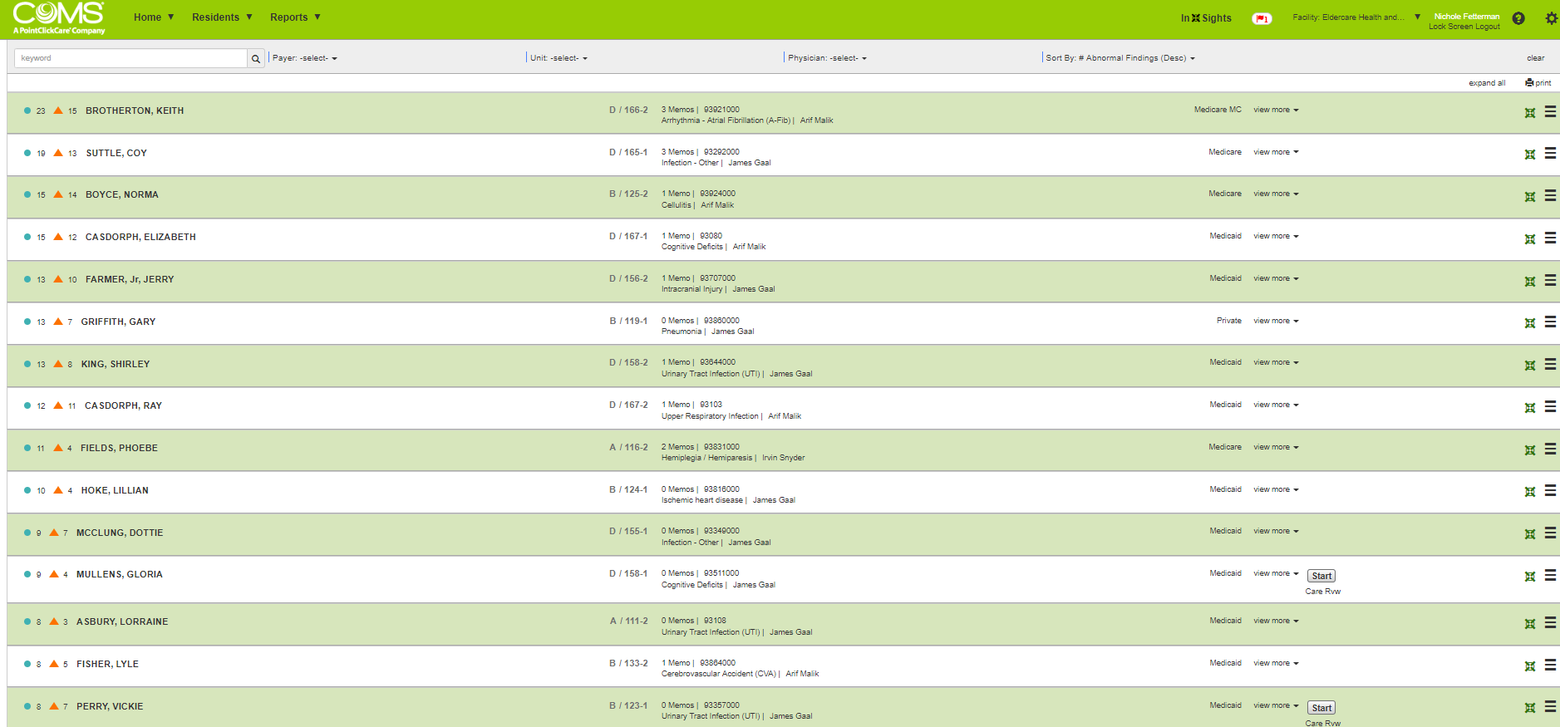

Providers:

Change Arif Malik to Arron Miller

Change James Gaal to Jim Gale

Change Irvin Snyder to Abigail Simpson

Residents:

Brotherson, Keith = Carney, Keith

Suttle, Coy = Case, Don

Boyce, Norma = Boyd, Nancy

Casdorph, Elizabeth = Smith, Stella

Farmer, Jerry = Farmer, Fred

Griffith, Gary = Griffin, James

King, Shirley = King, William

Casdorph, Ray = Smith, Neil change payer to Medicare

Fields, Pheobe = Fields, Norma

Hoke, Lillian = Miller, Ann

McClung, Dottie = Merrix, Dottie

Mullens, Gloria = Brown, Audrey

Asbury, Lorraine = Dale, Paula

Fisher, Lyle = Fisher, Luke

Perry, Vickie = Perry, Brenda change payer to Medicare

\*have start / care review added to all medicare / managed medicare residents

Red outline when Sort By Abnormal Findings Desc is clicked on.

Red outline when Stella Smith is selected (anywhere in that line, it can be a big hot spot)